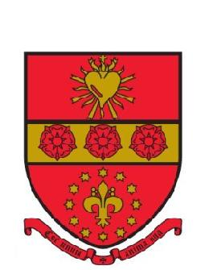

Job Description
Role: Kitchen Porter

This job description gives an overall indication of the areas of responsibility of the position, but is by no means all encompassing or fixed. The post may include other duties and responsibilities as determined by management that fall within the general responsibilities of the post. St. Francis’ College Limited (‘the College’) is an equal opportunities employer.

Location: | St-Francis collage Letchworth
Accountable to: | The Kitchen porter is directly responsible to and supervised by Catering manager However, the kitchen porter may also receive instructions from the Chefs and the Senior catering assistants, Or from the Deputy Head who is Line Manager for the Catering Manager, Or directly from the Head, who is responsible for the leadership and management of the College
Responsible for: | Working in a timely manner, making sure that the everyday tasks are completed, including following and signing off the cleaning schedule, fridge temperatures. That deliveries are put away and signed off and general cleaning tasks are completed.

Overall Purpose of the Job

The Kitchen porter’s primary purpose is to clean and tidy the catering areas after the chefs, to assist them to provide safe, nutritious food for the children, staff and customer bookings and to work as part of a team to help achieve the overall aims of the College.

Main Duties and Responsibilities

- Clean pots, pans and other basic catering equipment
- Clean dishes and cutlery manually and by use of a dishwasher
- Clean large industrial catering equipment
- Put away food, chemical and other deliveries using stock rotation
- Assist in the general day to day cleaning set out in the cleaning schedule
- Assist in general due diligence, such as daily fridge temperature recording
- Removal of general waste, food waste and waste oil
- Sweeping and mopping the Kitchen floors and cleaning of spillages in dining room
- Comply to all H&S and COSHH practices

General
Owing to the presence of pupils in the College, strict rules governing staff behaviour and, in particular, regarding access to areas of the College, are in place. Details may be obtained from the Deputy Head.

Training and Work Equipment

The Kitchen porter will be expected to take part in level 2 Food Hygiene Training and Child Protection Training. The College will provide training or pay reasonable training costs where the need arises. “Everyday” work equipment and Personal Protective Equipment, if required, will be provided by the College.

Person Specification
Role: Kitchen Porter

Essential | Desirable
Education:  - GCSE English or equivalent | Education:  - Food Safety Level 2
Skills:  - Team player  - Good communication skills  - Fast learner  - Ability to work on your feet  - Follow instructed H&S rules  - Good organisational skills | Skills:  - Basic food preparation
Experience:  - Working within a team  - Communicating with co-workers | Experience:  - Previous similar role  - Using chemicals safely  - An understanding of COSHH
Knowledge:  - Basic cleaning skills | Knowledge:  - Knowledge of food hygiene practices
Other:  - Open and friendly  - Approachable  - Treats everyone fairly and equally | Other:

